PROJECT: AITOFAMCAFET/01-2020

TERMS OF REFERENCE (TOR)

CONTRACT SERVICE FOR CAFETERIA SERVICE
FOR ASIAN INSTITUTE OF TECHNOLOGY

Date of Submission of Menu and Price List: | 28 February 2020

- BACKGROUND

The Asian Institute of Technology (hereafter refer to AIT), established in Bangkok in 1959, is a leading regional postgraduate institution in the Asian-Pacific region. AIT operates as a self-contained international community with academic buildings, laboratories and accommodation units for staff and students in its campus which located at km.42, Paholyothin Highway, Klong Luang, Pathumthani Province, Thailand.

AIT is seeking for the Food Court Vendor (hereafter refer to FCV) to provide food service at 1 vacant counter in Cafeteria. FVC will be operated under the supervision of Office of Facilities and Assets Management (hereafter refer to OFAM) who is an administrative unit of AIT responsible to manage all assets and facilities, and to coordinate and supervise all the subcontract works under AIT.

The objective of this TOR is to establish scope of service with FCV to provide food services and support cafeteria management to serve AIT international community consisting of students, employees, residents and visitors.

- PERIOD OF PERFORMANCE

The works foreseen under this TOR are to begin the contract as soon as possible with initial contract of one (1) year with a possibility of renewal for another one (1) year based on performance. FCV should be ready to come in before that contract commencement, if required.

At the time of termination/expiry of the contract, FCV will have the liberty to either, remove all its materials, or to, hand over/sell to the next service company. In case during the period of contract, FCV decides to terminate the contract, a notice for a period of not less than 3 months must be given to AIT.

- FCV’s SCOPE OF SERVICES/ RESPONSIBILITIES

- FCV’s shall be responsible to provide food service at the vendor space at the existing 3rd stall of the Cafeteria for Thai and Vegan Food for seven (7) days a week from 7:00 a.m. to 9:00 p.m.
- FCV shall follow the selling rates at: 1) A One (1) specific main dessert should not cost more than 35.00 Baht. If there are special Thai and Vegan Food that would cost higher than stated, it must be approved by OFAM before being implemented.
- FCV shall strictly maintain food safety, cleanliness & hygiene in their service as well as their vendor space area. In addition, FCV must pass the quarterly food and hygiene survey performed by OFAM. In case the survey report show unsatisfactory performance, FCV shall be given a notice by OFAM to improve the performance within one week. If the service of the vendor is still not satisfactory, FCV’s contract may be considered to terminate with advanced notice.
- FCV shall be responsible to continuously improve the services and attract more customers by maintaining the variety and taste of the food.
- The FCV shall make sure that the service counter shall be manned by at least one person serving the customers and can speak minimum English.
- The FCV shall properly maintain the Cafeteria existing infrastructure and shall bear the cost if any damage is caused during the service period.
- On the expiry date or earlier termination of the agreement, FCV shall be vacated peacefully and hand over the space to AIT in the condition as it was received.
- FCV is responsible to assess for any repair of existing AIT infrastructure at vendor space and report to OFAM with the details of the repair needed.

- FINANCIAL TERMS

- The benefit shall be based on Revenue sharing 80-20% basis. FCV shall be paid 80% of the revenue which is calculated from AIT Cash card system, on a weekly basis.
- FCV shall pay an initial deposit of 20,000 baht which is refundable at the end of the contract.
- FCV shall be responsible to pay electricity and water bills based on the meter reading at AIT rates.
- FCV shall be responsible for providing the LPG supply, potable water supply for its use in the preparation of cooking, all cutlery, all cooking utensils, all kitchen appliances, and others as necessary.

- AIT’S RESPONSIBILITIES

- AIT shall provide to the vendor gas stove, refrigerator/freezer, sink for washing utensils.
- AIT shall provide water and electricity meter for reading the consumption at vendor space.
- AIT shall provide the plates, spoons, trays and glasses to serve the food to the customers.
- AIT Janitorial service staff shall only be responsible for removal of the waste, sorted at designated area by the vendors of the cafeteria.
- AIT Technical service shall provide service in response to FCV’s complaint by Facility Infrastructure Management System (FIMS), email or phone for repair or replacement pertaining to AIT infrastructure e.g. building, electrical system (internal wiring, circuit boards, etc.), water and wastewater system (drainage pipes, water supply pipes leakages or blockages).

- QUALIFICATIONS OF THE FOOD COURT VENDOR

- FCV must be a company/an individual in Thailand.
- FCV must have no record of offence in any case in accordance with Thai law.
- FCV and the key staff (at the level of supervisor), assigned by FCV must be able to communicate in English, orally and preferably in writing also.
- FCV must not have any benefit from the other service companies in the bidding process.

- INSTRUCTION FOR PREPARING PROPOSAL

- FCV is required to study carefully the contents of this TOR and to obtain all information as it may require to enable it to submit its menu and price list. FCV shall be deemed to have satisfied itself as to the correctness and sufficiency of its menu and price list.
- Prior to submit a complete proposal document, FCV at its own responsibility, is encouraged to visit and inspect the site and to satisfy itself in all matters relating to the nature of the work, the means of access to the site and any other issues which could influence or affect the completion of the works within its proposed fee and within the proposed time.
- The proposal may be preferably written in English or Thai. The proposal must include in details the cost break down as requested in the selection.
- FCV is advised that FCV shall not be reimbursed for any costs, expenses incurs in assessment of facilities and preparation of proposal.
- FCV may also provide related document of the contract, certifications/work experience if any and the bidding envelope to AIT.
- FCV shall provide a recent medical certificate taken within a month after awarding contract.
- Upon receipt of this TOR, FCV must complete and promptly submit their proposal to Purchasing Office together with the menu and price list on or before the date stated.
- The proposal shall remain open for acceptance by AIT and irrevocable for a period of ninety (90) days after the closing date.
- AIT shall agree not to disclose nor make proposal of the unsuccessful FCV, available to any third party.
- Should FCV find discrepancies in, or omissions from, the TOR, or have any doubt as to the meaning or intent of any part hereof, FCV shall at once notify AIT by writing to Purchasing Office with the attention to:
● Mr. Vasvan: Tel. 0 2524 5027 or vasvan@ait.ac.th
● Mrs. Elizabeth: Tel. 02 524 6323 or bethc@ait.ac.th
- Any required additional information or clarification shall be responded by AIT in writing, and shall be circulated to all the Service Company. All bulletins shall be deemed to become part of the TOR. Oral instructions, corrections or interpretations shall not be bound.
- AIT reserves the right to reject all or part of menu and price lists.
- AIT reserves the right to award any vendor as appropriate and suitable.
- AIT reserves the right to test the taste of food proposed by FCV by AIT committee before awarding process.

8. CAFETERIA LAYOUT

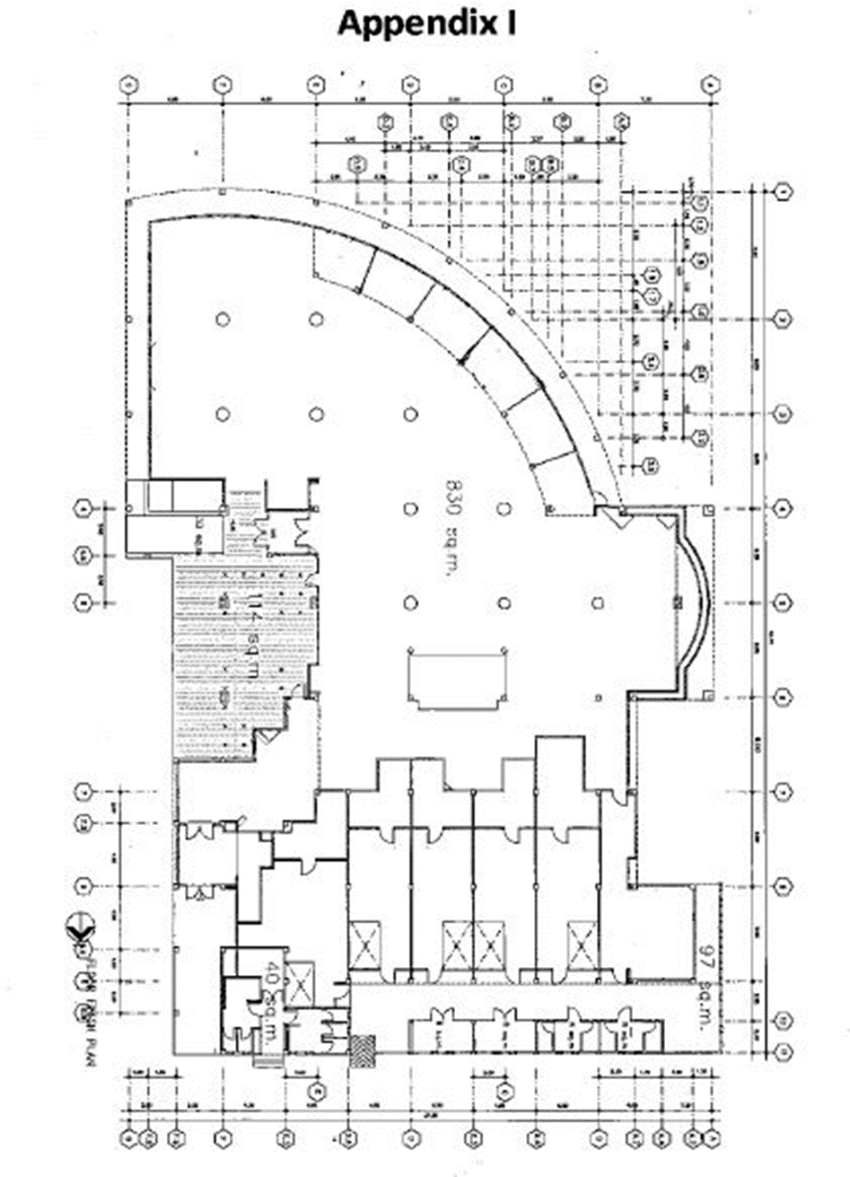
Thai and Vegan Food

