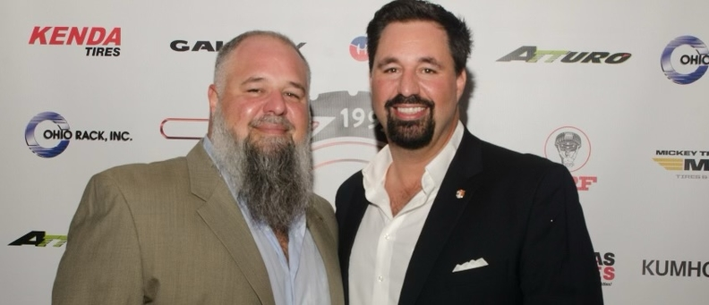

Photo caption: Tony Gonzalez (left) and his brother, Joaquin Gonzalez, pose during Tire Group International's 30th anniversary celebration Saturday, Dec. 16th in Miami.

MIAMI — The Gonzalez family couldn't let the year end without celebrating a significant milestone.

[Tire Group International Inc.](https://www.tirebusiness.com/opinion/detore-some-best-practices-top-workplaces) (TGI), the family-owned tire wholesaler, welcomed close to 300 guests Dec. 17 for a gala celebrating the company's 30th anniversary.

The event, held at the posh Penthouse at Riverside Wharf in Miami, brought together a group of suppliers, sponsors, invited guests and several TGI employees — called teammates — for dinner, drinks and music in the backdrop of the Miami skyline.

"Thank you for joining us to celebrate our anniversary," TGI President Joaquin Gonzalez told the assembled gathering. "We are incredibly thankful for all of you have done to make this possible. We would not be here without you."

Photo caption: TGI President Joaquin Gonzalez talks to attendees of the company's 30th anniversary gala, held Dec. 17 in Miami.

TGI also threw a cocktail party for out-of-town guests at the Courtyard by Marriott Miami Coconut Grove on the eve of the gala.

The event had been planned for several different times earlier in the year but complications, particularly the COVID-19 pandemic, delayed the event until mid-December.

Tony Gonzalez, Joaquin's elder brother, founded the company at age 23 in 1992 as a tire brokerage operating out of the garage of his family's home in Miami. The brothers' father had operated a tire shop in their native Cuba before emigrating to the U.S.

"It's been a remarkable 30 years for us, growing to become the company we are today," Tony Gonzalez said. "We are a family that works together, grows together and takes pride in everything we do."

Photo caption: Dominick Montouri (far right), president of Mickey Thompson Tires, lauds Joaquin Gonzalez (far right) and Tony Gonzalez during TGI's 30th anniversary celebration, held Dec. 17th in Miami.

Today, Miami-based TGI distributes more than 30 brands of tires and does business in more than 80 countries.

One of those brands — Mickey Thompson Tires & Wheels, represented by President Dominick Montouri and Vice President of Sales Todd Pickens — presented an award to the brothers in recognition of the milestone anniversary.

TGI focuses on several several private brand tires, including its proprietary Cosmo brand and a handful of others for which it has secured exclusive distribution rights.

Photo caption: A pair of tin characters pose during the TGI 30th anniversary celebration on Dec. 17 in Miami.

TGI, which has a little more than 100 employees, was the winner of the [2021-22 Best Places to Work survey](https://www.tirebusiness.com/best-places-work/tgi-winner-2022-best-places-work) sponsored by *Tire Business*.

The award, which is administered by Best Companies Group (BCG), an independent research firm specializing in identifying and recognizing great places to work, ranks retail, commercial, OTR retread or wholesale tire dealerships in the U.S. with at least 15 employees.

TGI was a runner-up previously before earning the award outright this past year.

"When you work for something you believe in, it's called passion," Joaquin Gonzalez said earlier this year.

"TGI has been inspiring belief and committing to it, since its humble beginnings, empowering our team to be the very best at everything we do."