What is the JACK service – white paper

Net Works Consulting Resources created the JACK service, for their clients, to make the IT support environment proactive vs. reactive. Jack is a SaaS (software as a service)product that is loaded on your PC and Servers and not only monitors all of the critical aspects of your equipment, but actually fixes the top 50 issues that plague the networking environment. We developed this service so our clients could go about their day without the annoying issues that come up and ruin productivity. Jack has many features, but the key items are;
- Monitors and reports on over 500 different key items on your equipment
  - If there is any critical items that JACK cannot fix, our technicians are only a phone call away
- Repairs issues and restarts critical services on PC’s and servers
- Has integrated, enterprise level, Anti-Virus and Anti-Malware software that scans multiple times a day, without slowing your machine down
- Complete Asset management system
  - It is easier to plan and budget if you know what PC’s / Servers you have on your network
- Health Report
  - Detailed list of each computer with key categories graded by a dashboard that is Red/Yellow/Green
  - Easy to read summary of what your network health looks like and if there are any areas of concern
  - You don’t need to be technical to read this report and know something needs attention
  - The report is sent to you on a monthly basis
- Keeps your PC’s and Servers running as fast as they did the day you bought them
Jack is like a technician, working 24/7/365 on your computers and servers to make sure they are able to function properly, when you need them. JACK will lower your IT support cost by 2x or 3x from what our research has shown with our current clients. Below is an example of one of our clients actual ticket count before and after JACK. The results are amazing!
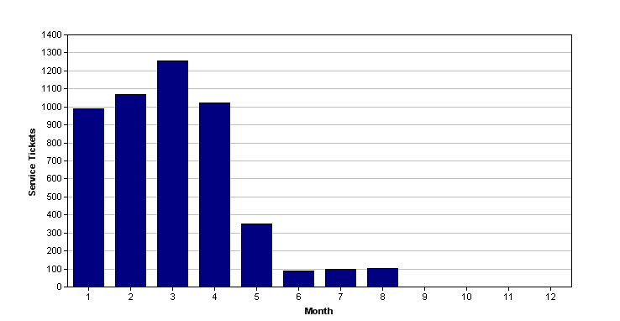

Jack has been built for the working professional that just wants a functional, calm and productive network environment. Simple, affordable and effective!

