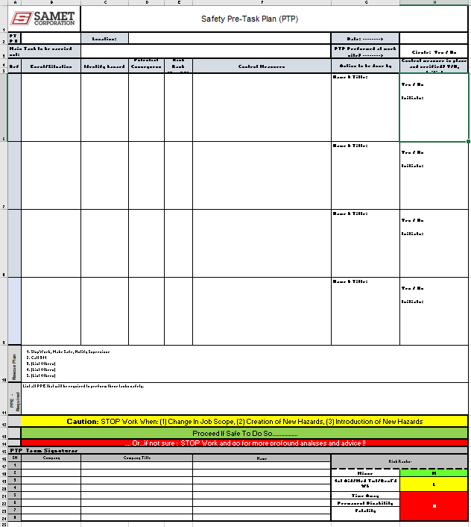

Link to Excel Sheet: PTP
This checklist must be filled out by a supervisor at the beginning of each day, and prior to the beginning of a new job/task.

Job Description:

Location:

 | YES | NO | NA
PPE
Face Shield
Gloves
Hearing Protection
Respirators
- Proper / Appropriate
- Training
- Fit test
- Medical
Safety toe Shoes
Safety Glasses
Hard Hat (bill forward)
Reflective Clothing
Proper clothing: long pants, 4” sleeve on shirt
HOUSEKEEPING
Aisles, stairwells, doors, electric panels clear
Cords off floor
Materials stored and stacked neatly
Floors swept daily
Flammables stored separately
Proper lighting
Egress marked
Trash cans provided
FIRE PROTECTION
No smoking in wood buildings
Fire extinguishers charged/in place
Fire watch as required
Hot work permit as required
POWER TOOLS
Inspected Daily
Cords in good condition
Plug UL approved for tool
Guards in place
HAND TOOLS
Inspected daily (see attached form)
In good condition
Tools tethered @ elevated work
STRAIGHT LADDERS
Inspected daily (see attached form)
Tied off
Extend 3’ above landing
Set up 4:1 20:5
Work between rails/no leaning
STEP LADDERS (>250#)
Inspected daily
Fully opened and locked
Work between rails/no leaning
No straddling / sitting on
Only 1 person on a ladder

 | YES | NO | NA
SCAFFOLDS (>6’)
Competent person
Inspected daily
Solid footing, bases, mud sills
Fully planked
Top rails / mid rails / toe boards
Secured / tied off
FALL PROTECTION SYSTEMS
Trained & competent person
PFAS Worn properly
Proper anchor points
Harness & Lanyard inspected daily
All openings guarded
Roof and floor penetrations guarded & labeled
100 % tie off as required
MECHANIZED EQUIPMENT
Inspected daily
Trained and competent operators
Audible backup alarms
Seat belt worn
Chain secured/latch closed
MATERIAL HANDLING
Load secured
Daily crane inspection
Proper Lifting techniques
Proper Equipment – Weight Limits
Slings, chokers, chain inspected
Tag lines needed
Spotter as required
Qualified rigger
Knowledge of signals
Stretch before lifting
TRENCHING/EXCAVATION
Competent person:
Utilities – verified and marked, 811 Called
Soil type – Rock A B C
Barricades
4 feet deep = ladder every 25 feet
5 feet deep = shoring, sloping, etc.
4 feet deep – air testing if hazard exists
ELECTRICAL
GFCI protection
Energized panels covered and locked
PPE – FR clothing, v rated tools etc.
Extension cords inspected (14AWG >)
Ground pins intact

SEPARATE PERMITS REQUIRED | YES | NO | NA
Excavating/Barricade
Hot Work (Welding/cutting)
Hot Work (Electrical)
Confined Space
Shutdown/Tie-In
Roof/Floor/Wall Penetration
Lift Plan
Unusual Job Plan

 | YES | NO | NA
SIGNS AND BARRICADES
Red tape – warning signs attached
Yellow tape
Warning signs with names of contractor and contact person & phone number
> 48 hours – permanent barricades
LOCKOUT / TAGOUT
ID isolation points – written procedure
Locks for all authorized persons
Tags available (name, date, company)

 | Have there been any incidents and accidents today? |  | Yes: ☐ | No: ☐
 | If Yes, have they been reported to Samet? |  | Yes: ☐ | No: ☐
Comments / Additional Information and/or Instructions:

Contractor:
Supervisor: |  | Date:

Crew Names: | Initials (AM Review) | Initials (PM Review)

