Primary Teacher
Application Form

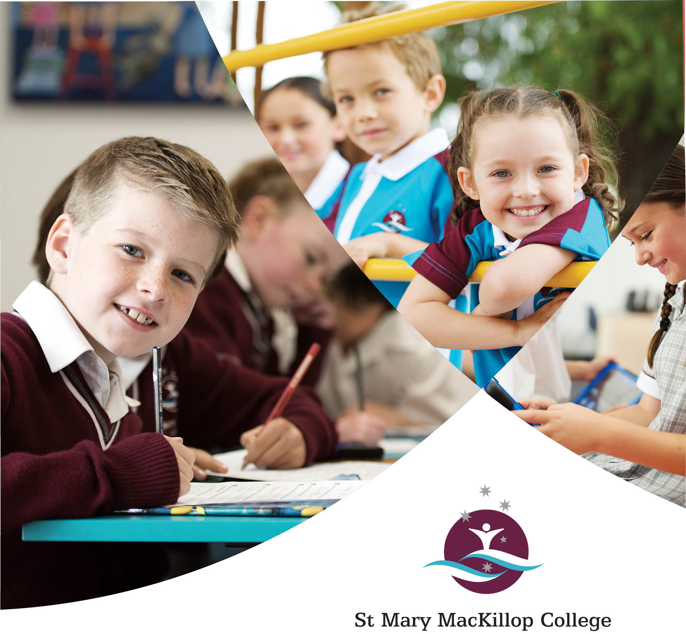

Applications are to be made on the enclosed form and submitted with the additional information requested.

Teacher Application Form

POSITION APPLIED FOR:

ADVERTISEMENT SEEN: (please circle)

- Seek | - CEWA Website | - The West Australian | - College Website
Applicant’s Details

NAME: Miss/Ms/Mrs/Mr:
ADDRESS:

PHONE: (H) PHONE: (W)
(MOBILE): EMAIL:

RELIGIOUS DENOMINATION:
Qualifications

EDUCATIONAL QUALIFICATIONS

Qualification | Name of Institution | Year Obtained

OTHER QUALIFICATIONS
(E.g. Senior First Aid Certificate, Bus Licence, Bronze Medallion). Include year qualification was attained and institute attended, if applicable.

Teaching Experience
Indicate in order, positions held, commencing with current or most recent. (Beginning Teachers should list three most recent practice teaching experiences.)

TOTAL FULL YEARS OF TEACHING EXPERIENCE:

Employer | Dates | Year Level Taught | Full Time  Part-Time (FTE)
Extra-Curricular Qualifications/Experience
Provide details of any extra-curricular experience, the role, responsibilities and length of time in the position.

Employer | Dates | Extra-Curricular Roles | Responsibilities

Professional Development

PROFESSIONAL DEVELOPMENT (undertaken in the last 4 years)

Professional Development | Dates | Relevance to Role

CEWA ACCREDITATION
(please provide details of accreditation you have attained if applicable)

Year | Details
Parish/Community Involvement
Describe ways you are/have been involved in your Parish and/or Community

Professional Associations
List membership of professional and / or teacher associations

Describe your experience, knowledge and vision that places you in an excellent position to undertake this role.
Please refer to the skills and attributes listed in the advertisement and the Job Description when addressing this.

Describe your experience, knowledge and vision that places you in an excellent position to undertake this role – continued

Referees

Names and addresses of persons who have consented to act as referees. (The Principal reserves the right to contact persons not nominated by the applicant.)

CURRENT EMPLOYER

Name:

School:

Contact Telephone Number:

PREVIOUS EMPLOYER (if applicable)

Name:

School:

Contact Telephone Number:

PROFESSIONAL REFEREE (a person with whom you have worked)

Name:

Position:

Contact Telephone Number:

PROFESSIONAL REFEREE (a person with whom you have worked)

Name:

Position:

Contact Telephone Number:

PARISH PRIEST/MINISTER (if applicable)

Name:

Position:

Contact Telephone Number:

Checklist:

- Letter of Application
- Current Resume

Copies of:
- Academic Transcripts
- TRBWA Information
- Accreditation Certificates
- Working with Children Check

Please note: In accordance with the Government’s health directions, proof of COVID-19 vaccination or an original copy of a valid exemption will be required as part of our recruitment process. You do not need to send this as part of your application, this will only be required from shortlisted applicants.

Please note: Attach this Application Form to your Letter of Application detailing other personal details that may be relevant to the position along with the listed attachments, and address to:

The Principal
St Mary MacKillop College
PO Box 5370
West Busselton WA 6280

Or email to:

Recruitment@mackillop.wa.edu.au

All staff applying for positions at St Mary MacKillop College are asked to read the attached ‘Vision Statement’ as well as the following ‘Statement of Principles’

Important Employment Collection Information for Applicants

• In applying for this position you will be providing the College with personal information.

• Personal information, contained in the application or on your curriculum vitae, will be collected in order to assess your application. This information may be stored by the College, but will not be disclosed to any third party without your consent.

• It is your responsibility to inform nominated referees that you have passed on their contact details and the reason for this. All nominated referees of shortlisted candidates will be contacted.

• You may seek access to personal information held about you if you are unsuccessful for the position. However, there will be occasions where this is denied. Such occasions would include where access would have an unreasonable impact on the privacy of others. Application forms and other personal information of unsuccessful applicants will be destroyed on completion of the appointment process, unless you give signed permission for your application to remain on file.

• Your application must include the appropriate documentation required for the position.

TEACHING IN A CATHOLIC SCHOOL

A Statement Of Principles

The philosophy of Catholic education has been expressed in many Church documents since the Second Vatican Council. Whilst the Catholic school is accountable to the community for the provision of quality education to its students, it is accountable also to the Church community for providing this education within the context of Gospel values as espoused by the Catholic tradition. The Catholic school is more than an educational institution: it is a key part of the Church, an essential element in the Church’s mission.

The Catholic education philosophy reveals a concern for an education which combines sound knowledge and skills with an overall personal development based in Christian values. Such an education is dependent for its effectiveness on a high level of interpersonal relationship between teacher and pupil through which the teacher witnesses to the essential values of Christ.

Teachers in the Catholic school are more than employees. They minister in the name of the Church and of the Gospel and as such participate actively in the life of the Church and have a pastoral concern for each individual student.

It is expected all teachers employed in a Catholic School will perform conscientiously and competently the duties, both teaching and non-teaching, they are assigned by the Principal in accordance with normal practice in Catholic schools.

Teachers should help maintain an atmosphere of charity and justice within the school, as would be expected in a community and help ensure the provision of the Catholic religious perspective in the teaching and learning process and in all activities of the school in which staff and students engage.
All teachers have a responsibility to develop and maintain an adequate understanding of those aspects of Catholic teaching which relate to their subject areas. By their example, all teachers provide a Christian leadership role for all members of the school community.

Only a person supportive of Catholic Educational philosophy may be a teacher in a Catholic school. Teachers bear witness to Christ and Christian values in their own conduct and by personally supporting, evaluating, developing and disseminating the Catholic school philosophy.
The Catholic School and the teacher in the Catholic School are committed to extending the invitation of Jesus to “Come, Follow Me”.

The objectives which teachers in a Catholic school undertake to support and promote require them to:
- give regular and efficient instruction for the academic, physical and spiritual development of the pupils;
- participate in worship and prayer in the school;
- adhere to Catholic principles and by personal example, integrity and behaviour, support Catholic moral standards.

DECLARATION

I declare that the information in this application is complete and correct in every detail.
I understand that deliberate inaccuracies or omissions may result in non-acceptance of this application and/or termination of employment. I have read the above “Teaching In A Catholic School: A Statement of Principles” and concur with its contents and agree to support the objectives outlined.

Signature: Date:

VISION STATEMENT

OUR VISION
St Mary MacKillop College is committed to the traditions of the Sisters of St Joseph, our patron Mary MacKillop and the example they provide. The College strives to be a welcoming and respectful faith community, where individuals learn and grow together, embracing life and choosing to serve.
OUR MISSION
Our mission is to provide a quality holistic education in the Catholic tradition for all students in our community who will choose life with courage, in the spirit of St Mary MacKillop.
OUR CORE VALUES
We are a Christian community that fosters a love of learning, the development of the whole person, and an openness to meaningful relationships with God, self and others. Our decision making is grounded in our core values – these are our FIRST consideration. The following core values underpin our approach:
Faith - we support a spiritual journey informed by our Catholic Christian tradition, gospel values and of putting faith into action. As a community we value and provide opportunities to develop faith in oneself, in others and in God.
Inclusion - we are a welcoming community where students have a sense of belonging. We forge strong relationships with the wider community and through respectful collaboration call forth the contributions of each other. We are especially committed to including those on the margin and in need, as Mary MacKillop did.
Respect - we value, support, and affirm the unique gifts of each person, and the gift of diversity. We respect and care for the environment and model respect for ourselves, and for others in our attitudes and behaviour, and in College policies and practices.
Service - we are guided by the example of our patroness – St Mary MacKillop, whose belief: ‘never see a need without doing something about it’ calls us to serve others. In this service of others we choose life in its fullness and realise that it is in giving that we receive.
Truth - we strive to live authentically from deeply held beliefs about what it means to be human, and to live with faith and purpose. We are genuine about who we are and what we aspire to be. We seek always to live our values and to ‘walk the talk’.

