Teacher Assistant
Application Form

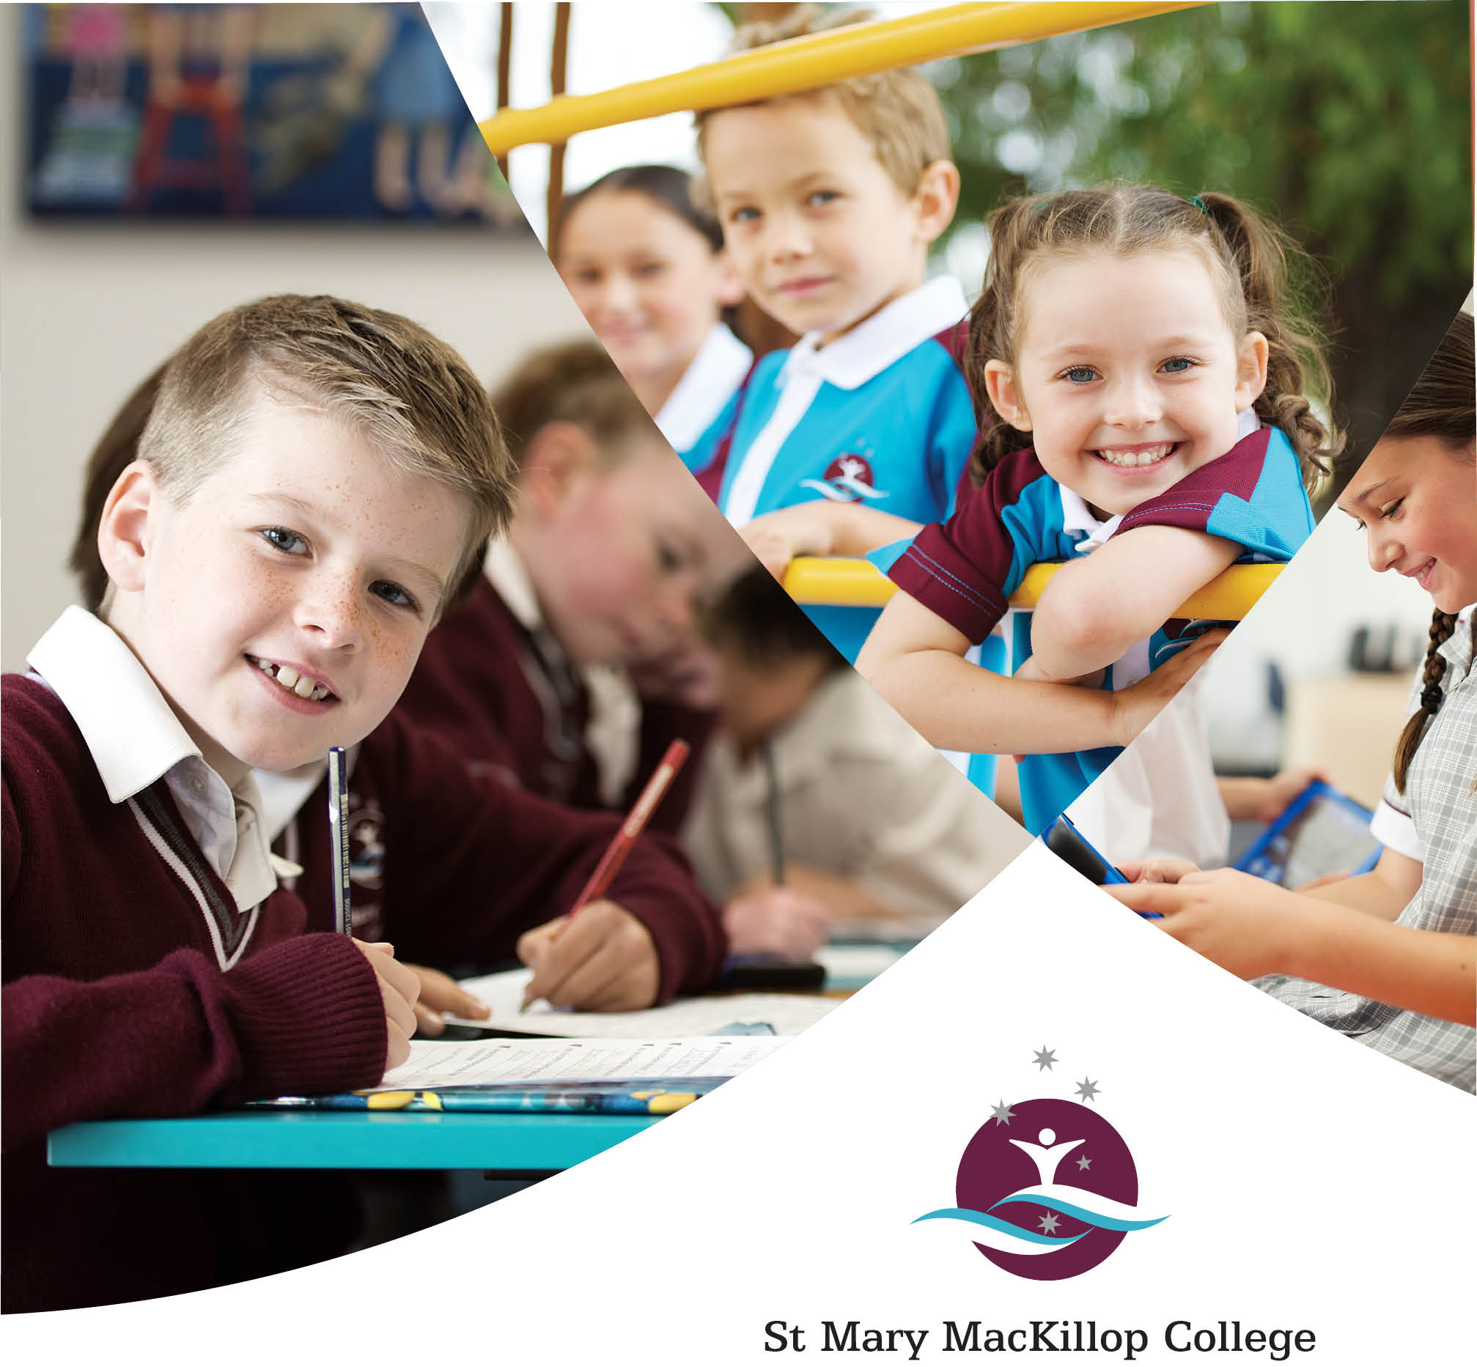

Applications are to be made on the enclosed form and submitted with the additional information requested.

POSITION APPLIED FOR:

ADVERTISEMENT SEEN: (please circle)

- Seek | - CEWA Website | - The West Australian | - College Website
Applicant’s Details

NAME: Miss/Ms/Mrs/Mr:
ADDRESS:

PHONE: (H) PHONE: (W)
(MOBILE): EMAIL:

RELIGIOUS DENOMINATION:
Qualifications
EDUCATIONAL QUALIFICATIONS

Qualification | Name of Institution | Year Obtained
Have you attained any of the following (please attach copies):
 | Bus Licence | Date obtained:
 | Bronze Medallion | Expiry Date:
 | First Aid | Expiry Date:
The following are essential requirements:
 | Working With Children Check | Expiry Date:
 | CRIM TRAC | Date obtained:

Experience:
Tell us about what experience you have had in a similar role:

Please comment on your knowledge, skills or experience in each of the following areas:
Familiarity with the operation of a school:

Organisational Skills:

Dealing with confidential information:

Describe the first steps you would take in addressing the Key Responsibilities listed in the job description:

Referees
State name, address, phone number and position held of referees who may be contacted regarding professional experience and character.

CURRENT EMPLOYER

Name:

Business:

Contact Telephone Number:

PREVIOUS EMPLOYER (if applicable)

Name:

Business:

Contact Telephone Number:

- I have advised the above referees they have been included on this application form.
Declaration
I declare that the information in this application is complete and correct in every detail. I understand that deliberate inaccuracies or omissions may result in the non-acceptance of this application and/or termination of employment. I have read “Working in a Catholic School: A Statement of Principles” and concur with its contents and agree to support the objectives outlined. I acknowledge the Employment Collection Notice which is distributed in accordance with the Privacy Act 2001.

Signature:

Date:
WORKING IN A CATHOLIC SCHOOL
A STATEMENT OF PRINCIPLES

The Catholic school forms part of the saving mission of the Church especially for education in faith. It is a privileged means of promoting the formation of the whole person.
Staff are commissioned to participate in the mission of proclaiming the Good News to all and to invite all to live knowingly as children of God.
The Catholic school and staff in the Catholic School are committed to extending the invitation of Jesus to “Come, Follow Me.”
The philosophy of Catholic Education has been expressed in many Church documents since the Second Vatican Council. Whilst the Catholic school is accountable to the community for the provision of quality education to its students, it is accountable also to the Church community for providing this education within the context of Gospel values as espoused by the Catholic tradition. The Catholic school is more than an educational institution: it is a key part of the Church, an essential element in the Church’s mission.
The Catholic education philosophy reveals a concern for an education which combines sound knowledge and skills with an overall personal development based in Christian values. Such an education is dependent for its effectiveness on a high level of interpersonal relationship between staff and pupil which staff witness to the essential values of Christ.
Staff in the Catholic school are more than employees. They minister in the name of the Church and of the Gospel and as such participate actively in the life of the Church and have a pastoral concern for each individual student.
It is expected all staff employed in the Catholic school will perform conscientiously and competently the duties they are assigned by the Principal in accordance with the normal practice in Catholic schools.
Staff should help maintain an atmosphere of charity and justice within the school as would be expected in a community and help ensure the provision of the Catholic religious perspective in the teaching and learning process and in all activities of the school in which staff and students engage.
All staff have a responsibility to develop and maintain an adequate understanding of those aspects of Catholic teaching which relate to their work areas. By their example, all staff provide a Christian leadership role for all members of the College community.
Only a person supportive of Catholic Educational philosophy may be a staff member in a Catholic school. Staff bear witness to Christ and Christian values in their own conduct and by personally supporting, evaluating, developing and disseminating the Catholic school philosophy.
The objectives which staff in a Catholic school undertake to support and promote require them to:
- participate in worship and prayer in the school;
- adhere to Catholic principles and by personal example, integrity and behaviour, support Catholic moral standards;
- implement the policies of the College .

EMPLOYMENT COLLECTION NOTICE

1. In applying for this position you will be providing St Mary MacKillop College with personal information. We can be contacted on PO Box 886, Busselton, WA 6280, admin@mackillop.wa.edu.au or 9752 7500.
2. If you provide us with personal information, for example your name and address or information contained on your resume, we will collect the information in order to assess your application.
3. You agree that we may store this information for a period of six months.
4. You may seek access to your personal information that we hold about you if you are unsuccessful for the position. However there will be occasions where access is denied. Such occasions would include where access would have an unreasonable impact on the privacy of others.
5. We will not disclose this information to a third party without your consent.
6. We are required to collect information regarding whether you are or have been the subject of an AVO and certain criminal offences under Child Protection law.
7. You are to advise your referees that they have been included in your application. We also reserve the right to contact unlisted referees during the short listing process.
8. When the selection process is complete your application will be destroyed if you are not the successful candidate. If you wish your curriculum vitae to be returned you need to indicate this.

VISION STATEMENT
Our Vision
St Mary MacKillop College is committed to the traditions of the Sisters of St Joseph, our patron Mary MacKillop and the example they provide. The College strives to be a welcoming and respectful faith community, where individuals learn and grow together, embracing life and choosing to serve.

Our Mission
Our mission is to provide a quality holistic education in the Catholic tradition for all students in our community who will choose life with courage, in the spirit of St Mary MacKillop.

Our Core Values
We are a Christian community that fosters a love of learning, the development of the whole person, and an openness to meaningful relationships with God, self and others. Our decision making is grounded in our core values – these are our FIRST consideration. The following core values underpin our approach:

Faith - we support a spiritual journey informed by our Catholic Christian tradition, gospel values and of putting faith into action. As a community we value and provide opportunities to develop faith in oneself, in others and in God.

Inclusion - we are a welcoming community where students have a sense of belonging. We forge strong relationships with the wider community and through respectful collaboration call forth the contributions of each other. We are especially committed to including those on the margin and in need, as Mary MacKillop did.

Respect - we value, support, and affirm the unique gifts of each person, and the gift of diversity. We respect and care for the environment and model respect for ourselves, and for others in our attitudes and behaviour, and in College policies and practices.

Service - we are guided by the example of our patroness – St Mary MacKillop, whose belief: ‘never see a need without doing something about it’ calls us to serve others. In this service of others we choose life in its fullness and realise that it is in giving that we receive.

Truth - we strive to live authentically from deeply held beliefs about what it means to be human, and to live with faith and purpose. We are genuine about who we are and what we aspire to be. We seek always to live our values and to ‘walk the talk’.

